**DAILY ONLINE ACTIVITIES SUMMARY**

|  |  |  |  |  |  |  |
| --- | --- | --- | --- | --- | --- | --- |
| **Date:** | | | **07/06/2020** | **Name:** | **JASLINE SHARON TAURO** | |
| **Sem & Sec** | | | **4th sem, A Section** | **USN:** | **4AL18CS029** | |
| **Online Test Summary** | | | | | | |
| **Subject** | **N/A** | | | | | |
| **Max. Marks** | **N/A** | | | **Score** | **N/A** | |
| **Certification Course Summary** | | | | | | |
| **Course** | | | 1. **Trailhead Basics** 2. **Python for Machine Learning** | | | |
| **Certificate Provider** | | 1. **SALES FORCE** 2. **GREAT LEARNING ACADEMY** | | **Duration:** | | 1. **3 HRS** 2. **45 MINS** |
| **Coding Challenges** | | | | | | |
| Problem Statement: Write a C++ Program to swap two numbers using friend as a bridge concept. | | | | | | |
| **Status: DONE** | | | | | | |
| **Uploaded the report in GitHub** | | | | **YES** | | |
| **If yes Repository name** | | | | <https://github.com/jaslinesharontauro/C_Prgms/blob/master/swap_friend.cpp> | | |
| **Uploaded the report in slack** | | | | **YES** | | |

**Online Test Details: (Attach the snapshot and briefly write the report for the same)**

**Certification Course Details: (Attach the snapshot and briefly write the report for the same)**

**Coding Challenges Details: (Attach the snapshot and briefly write the report for the same)**

**CERTIFICATION COURSE DETAILS**

**Today I have done certification course on TRAILHEAD BASICS by SALES FORCE. I learnt about the Data Management. In which I learnt how to Import Data and to use the data import wizard in My Trailhead Playground. I completed this particular module.**

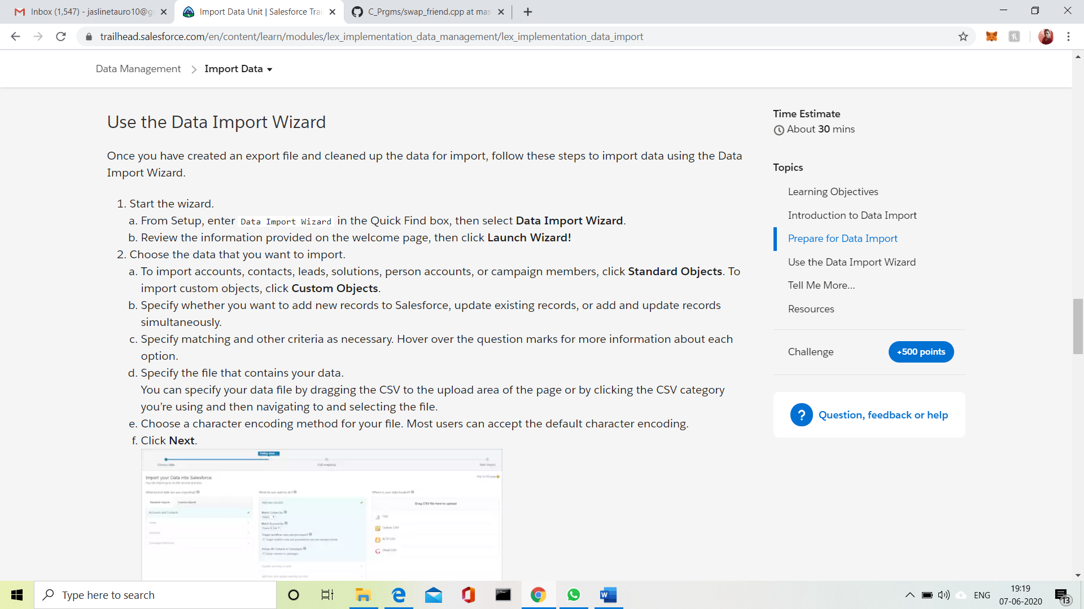

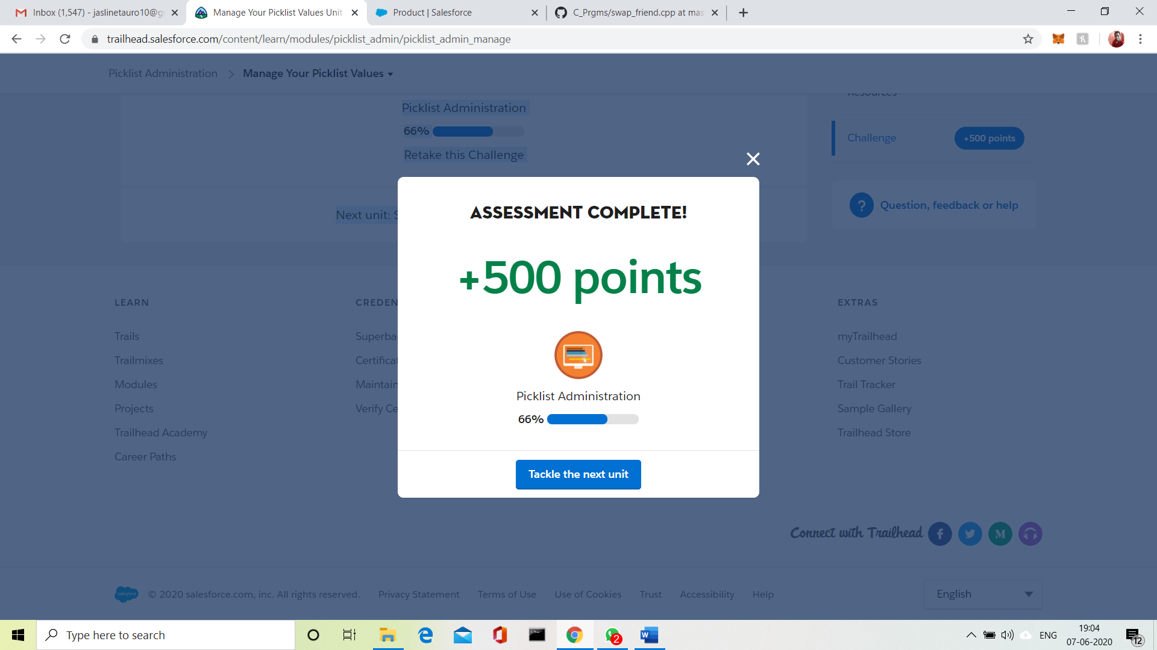

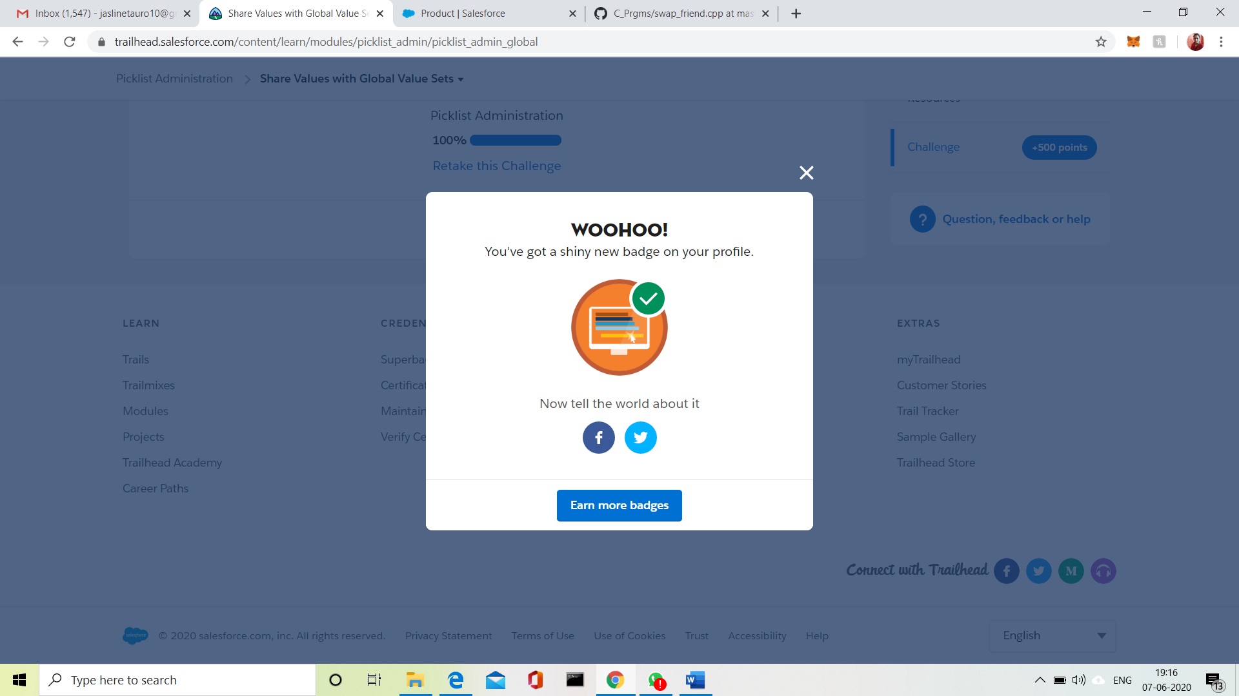

**And also, I have also completed the assessment on course PYTHON FOR MACHINE LEARNING course and I have received the certificate of completion. I have uploaded certificate in my GitHub account.**

**Below is the link of my GitHub repository**

<https://github.com/jaslinesharontauro/certificates>

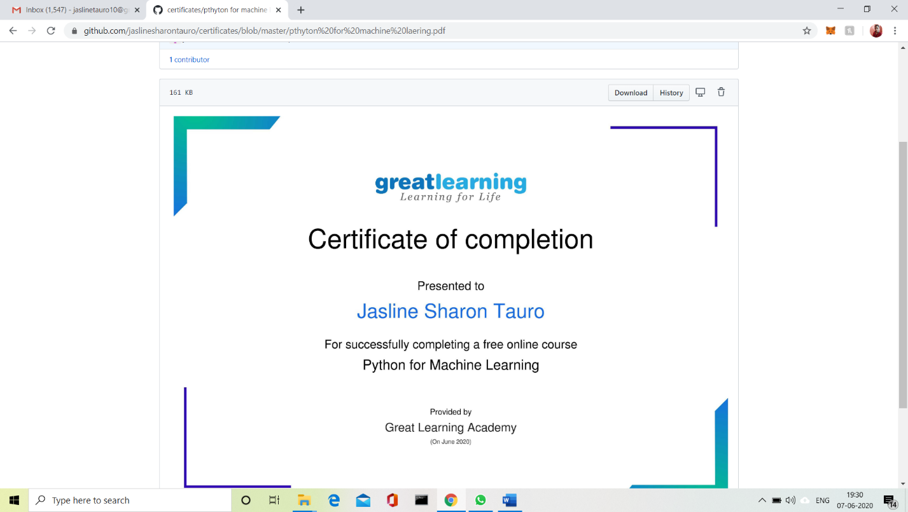

**CODING CHALLENGES DETAILS:**

**Problem statement:**

## Write a C++ Program to swap two numbers using friend as a bridge concept.

## Note- Don't make use of temp variable while swapping. Program should use the concept of **friend function** ***Example***

**Input**  
a=10  
b=20  
**Output**  
a=20  
b=10



 